This document has been prepared to help Lions Clubs embark on or enhance their existing Recycle for Sight Programs. This is a project which has broad interest in your community.

The “National Eye Institute, Glasses Crafter” gathered statistics showing over 75% of all Americans aged 1 to 104 wear some form of corrective lenses (64% wear glasses). Many people have multiple pairs of glasses due to prescription changes or for fashion. Eyeglasses are expensive (see CBC news item here). At the same time, the numbers of people needing corrective lenses that are impoverished and cannot afford eyeglasses is on the rise.

A Recycle for Sight Project in a club will help those in need stay productive members of the economy while offering clubs an opportunity to increase membership and enhance club success. I hope this guide will help you and your club experience renewed success.

This guide has been developed by: PDG Lion Jeffrey Friedman, Lions Clubs International District A-711 Recycle for Sight Coordinator 2012-2021 recycleforsight@a711lions.ca MD’A’. The current District A-711 Chairperson id Dave Bhatia of the Oakville Lions Club bhatiadave@yahoo.ca (647)294-2840.

Note: Most underlined words in this document are Hyperlinks, use “Ctrl + Click” to follow them.
Contents
Why Recycle Used Eyeglasses? Some Stats 2
The Need for Glasses – 153 Million Reasons Lions Recycle for Sight 2
What effort is required to run this Project in a Club? 3
Will, or does your club participate in the Recycle for Sight Program? 3
* Types of Eyeglasses we collect 4
Promotion of the Recycle for Sight Program 4
Suggested recycling activities 5
Where should we place Recycle for Sight Boxes 5
Make your Collection Points easy to find using www.recycleforsight.ca 6
Large Store Chain Arrangements: 6
* Latest News (Covid-19) 7
Other important Promotional Steps: 8
Resources to Grow a Recycle for Sight Program 8
Lions Recycle for Sight Collection Boxes 9
Canada Post Mailboxes 9
* Reporting and promoting with MyLion 10
* Packaging 11
* Shipping Instructions 12
Requests for Glasses for Missions 15
*Discount Programs for Lions Members 16
Appendix A: “Find a Club” shows “Eyeglass Collection Points” 18
* Appendix B: Shipping Companies / Arrangements 19
* Appendix C: Shipping Labels and Fragile Label 20
* Content items above starting with an *asterix* have been REVISED

Why Recycle Used Eyeglasses? Some Stats

The program was adopted as an oficial activity of Lions Clubs International (LCI) in 1994. However, Lions have been recycling eyeglasses for over 80 years.

One goal of the program is to meet the demand for quality eyeglasses in developing nations.

Currently, it costs less than 25 cents to provide someone with glasses. As an example, in fiscal year 2004-2005 the Lions reported a collection of approxiamately 5.5 million pairs of eyeglasses distributed to almost 3 million people in developing nations. Today the numbers are much larger.
“
- 253 million people are blind or have moderate to severe distance vision impairment (MSVI)
- 1.1 billion have near-vision impairment simply because they do not have a pair of glasses
- >75% of all blindness and moderate to severe distance vision impairment is avoidable
- 89% of people with visual impairment live in developing countries”
Above Information: sourced by Lions Clubs International

The Need for Glasses – 153 Million Reasons Lions Recycle for Sight

According to The World Health Organization, 153 million people have uncorrected refractive errors (near-sightedness, far-sightedness, or astigmatism). Most of these vision impairments are quickly diagnosed and easy to treat with corrective lenses.
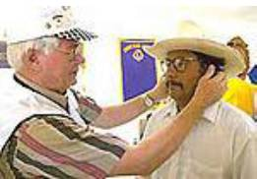
Still, millions of people in developing nations are pushed deeper into poverty simply because they do not have corrective eyeglasses. They cannot learn because reading is difficult. They cannot work to the best of their ability because they cannot see clearly.

It costs Lions less than US$0.25 to provide a pair of recycled eyeglasses and change someone's life.

For children, clear vision means a better education, healthier development, and a better quality of life. For adults, it means greater employment opportunity and economic strength. For seniors it means less dependence on others.

Lions clubs collect millions of eyeglasses each year to address the need for glasses, making eyeglass recycling one of our most popular activities.

Lions clubs send collected eyeglasses to one of our 18 official Lions Eyeglass Recycling Centres (LERC’s) in the world. The Canadian LERC (CLERC) is in Calgary, Alberta.
- At each LERC, Lions volunteer their time and services to prepare eyeglasses for distribution, cleaning and classifying each pair by prescription.
- Optical missions sponsored by Lions clubs and other groups distribute the donated eyeglasses to needy people throughout the world, in accordance with local laws.

According to the Program Ideas for Vision handout from LCI, Collecting used eyeglasses is listed first under the easiest Projects a club can undertake in the Vision Service area.
Lions Clubs have counted this project under either the Vision or the Environment categories.

What effort is required to run this Project in a Club?

Overall, this project requires moderate to low effort for success:
- Order Recycle for Sight Boxes from the Canadian Lions Eyeglass Recycling Centre (CLERC) or LCI (see Page 9) or make your own using the decals available from LCI (see Page 9).
- Ask owners of sites where people gather for permission to host a box (Page 5)
- Ensure you have put your club name and one or two contact phone numbers on the collection box so that site management can call you for box maintenance/emptying.
- Call site contacts periodically to see how full collection box is (Min. 2 times/year).
- Schedule time to drop by periodically and empty Recycle for Sight boxes or visit and empty boxes when you happen to be near a location; it is as easy as that.
- Sort and pack glasses and any hearing aids received for shipment as a regular event, or after a club meeting.
- Label the boxes for shipment (samples in Appendix C)
- Deliver or ship boxes of packed glasses to the Canadian Lions Eyeglass Recycling Centre in Calgary. Day & Ross Trucking will ship your glasses to the CLERC in Calgary for free (see page 13).
- Clubs may also direct their glasses collected to Mountaineer Movers Ltd. In Hamilton, Ontario who will store them until they can be forwarded to “the CLERC or to Medical Ministries International Canada” (MMI) in Hamilton Ontario.
- Report your eyeglass collection efforts in MyLion. (each pair is a person served)
- Help us promote this project to all Canadians by having and maintaining a list of your collection points on www.recycleforsight.ca. See page 4 for details.

Will, or does your club participate in the Recycle for Sight Program?

In either case please advise your District Recycle for Sight Coordinator of your club’s participation and your club’s prime contact for this project. Coordination of Club efforts on this project will lead to better promotion of your collection points to the public. Any club whether they participate or not, can promote www.recycleforsight.ca.

Clubs should review The Club Guide for Collecting Used Eyeglasses, access it by Clicking here.

Check out Lions International Resources for Recycle for Sight at https://lionsclubs.org/en/resources-for-members/resource-center/recycle-eyeglasses

* Types of Eyeglasses we collect

We collect new and used reading, single vision, bifocal, children’s, safety, and both prescription and non-prescription glasses and sunglasses (both clip-ons and glasses). Glasses may consist of glasses in frames, or uncut lenses.
Note: only soft eyeglass cases may be shipped to the Canadian Lions Eyeglass Recycling Centre – please dispose of all used hard eyeglass cases (unless they are new and unused).

The Lions in District A4 have suggested that we contact local Value Village Stores to determine whether they will accept used eyeglass cases to avoid their going to landfill.

Exception: If a donated pair has clip-ons, leave it in its case, or bag it before packing.

*The CLERC now accepts broken glasses and loose lenses.
Please place loose lenses and broken glasses in a separate box for shipping. Please label that box “loose lenses and broken glasses “. The CLERC has arrangements made to dispose of these without putting them in landfill. Broken glasses are broken down for their source materials while loose lenses are ground up – mixed with reflective paint and painted as lines on US highways.

Promotion of the Recycle for Sight Program

We want to collect more glasses so that we may provide them to those in need and we want more members of the public to know we provide this service. The key is to make it easy for the public to find their local collection points. Please share where you collect glasses from on a regular basis and we will list them at www.recycleforsight.ca . Send the following information to recycleforsight@a711lions.ca for each location: The location’s name; street address; city; province; postal code; phone number; sponsoring club; and whether the site is open to the public or private. This site also makes it easier to locate participating clubs when organizations offer to host a collection box and to confirm that a site is being served (we call once annually). We aim to keep the Lions Brand strong by not allowing boxes to become orphaned. A blank template spreadsheet for this purpose may be found at:
Recycle for Sight Collection Box Location - template version July 2020.xls

Clubs should entertain participation in this program to raise visibility in your community as a demonstration of “What Lions Do”. This is a project We can claim direct credit for. Whether you participate or not, you can still promote www.recycleforsight.ca.

Lions Recycle for Sight Boxes, Window Transfers, Posters, and other promotional materials are available to you to promote this project in your community (see Page 8).

We should leverage two annual events on the Lions Clubs International calendar:

- May is “Recycle for Sight” Month - Give your club’s eyeglass recycling program a boost and participate in this popular Lions activity.

- Lions World Sight Day (second Thursday of October) World Sight Day is an annual day of awareness that focuses on blindness and vision loss.

Please let your District Recycle for Sight Coordinator know if your club will join with other clubs in executing a District Wide Project to promote these events.

Suggested recycling activities

- Display the “Lions Recycle for Sight” poster and brochures at your collection locations to promote community awareness.
- Obtain a city proclamation to designate a special day in your community as the annual “Recycle for Sight Day. “
- List your collection sites in the local newspaper, community cable network, and your club’s Web site.
- Please send a list of your clubs collection locations to recycleforsight@a711lions.ca so they may be posted on the Recycle for Sight Webpage http://recycleforsight.ca Details on Page 4.
- Hold an eyeglass collection in coordination with a community health fair event, or a community “spring cleaning” initiative.
- Give a “Lions Recycle for Sight” presentation at a local school to get students and faculty involved.
- Work with Leos, Girl Scouts, Boy Scouts, and other youth groups to collect used glasses for you.
- Use Lions CIubs International’s public relations tools and resources to promote your eyeglass recycling program.
- Download the “Lions Recycle for Sight” logo on the association’s Web site www.lionsclubs.org for use in newsletters and other communications.

Where should we place Recycle for Sight Boxes:

• Banks | • City administrative center
• Coffee shops and restaurants | • Colleges and universities
• Commuter stations | • Dry cleaners
• Elementary schools | • Funeral homes
• High schools | • Lasik surgery offices
• Libraries | • Major department stores
• Major grocery stores | • Ophthalmologists’ offices
• Optometrists’ offices | • Pharmacies
• Places of worship | • Shopping malls
• Video stores | - Municipal Recycling Centres
Anywhere people gather

The Logo on our Recycle for Sight Boxes demonstrates what Lions Do. This can lead to new membership in your club with people who share our values and feel this project is important.

Make your Collection Points easy to find using www.recycleforsight.ca
(Open for participation by all Canadian Lions Clubs)

Please take the following steps to list your collection points on our website designed to let the public know where to drop off their usable eyewear across the District or anywhere in Canada. Visitors can now enter their Canadian Postal Code at www.recycleforsight.ca to be presented with a map with balloons indicating their closest collection points. Hover over the balloon to see site details.

Assist us in showing the popularity of this project, the wide availability of sites across Canada hosted by many clubs like yours. Above all else let us collect more glasses for the needy wherever they are:
- Send your list of collection points in a spreadsheet (use headings: Name of location/store; Street Address; City; Postal Code; phone number; sponsoring club name and whether the site is open to the public or private) to recycleforsight@a711lions.ca. Download the MS Excel template here. Each club is expected to manage their own collection boxes (emptying boxes and shipping any collected eyewear).

- We will ask your collection points owners/management to approve their name and locations being publicized on the Recycle for Sight website (directly accessible at www.recycleforsight.ca), (add a link to this site to your own club web-site, and add it to social media communications. This is essentially free advertising for the site.

- Large brand sites like Wal-Mart or Loblaws Real Canadian Superstore® locations may have special processes to go through prior to approving publicity. Email recycleforsight@a711lions.ca for assistance on this issue.

Large Store Chain Arrangements:

Loblaws Canada Stores: Lions Clubs have been given approval to place Collection boxes in the optical departments of all Loblaws / Real Canadian Superstore® and Zehr Markets® locations across Canada. Visit your local Loblaws Store Optical Department and place a collection box.

* Latest News
COVID-19 is an airborne pathogen. Glasses stored for any length of time should not be feared to pass on Covid-19. Please sanitize your hands before and after handling used eyeglasses.

Effective Lions Year 2020-2021 all service reporting in done at: MyLion https://app.mylion.org/

Wal-Mart Canada: Clubs have three approaches they can take in dealing with their local Wal-Mart Stores with respect to Recycle for Sight (#3 is the easiest):
- Ask the Store Manager to complete a “Charity Organization Questionnaire Form” (available on their Intranet). This if accepted will allow placement of a RFS Box in public areas of the store for up to seven days if accepted.**
- Visit www.walmartcanada.ca to see their criterion and apply for either a Donation of Space or a Community Grant. You can apply quarterly to each store, if granted you must wait a year before re-applying to that store.
- Ask your local Wal-Mart Optical Centre to collect used eyeglasses for this program. In general, they will hold collections in their back rooms for club collection. Work with the optical store’s manager - If the RFS box we provide is not blocking their merchandising space they may leave it in the front of the store otherwise they will hold it in their back room. In one store where we were forbidden to leave a box exposed to the public, they allowed us to mount the box on a wall by the front window above a fire extinguisher.

** Wal-Mart’s policies in Canada stem from their requirement to comply with US legistaion – the 2012 Foreign Corrupt Practices Act. Wal-Mart Canada will not agree to act as a single point of collection in Canada as they have in the USA, but Lions Clubs have been successful in placing boxes (in their back offices) at their local Wal-Mart Vision Centres in Canada– Just ask!

Day & Ross Freight www.dayross.com has agreed to transport our Lions Clubs used eyewear for FREE to the CLERC in Calgary. See further details under shipping below.

Luxottica Retail Group Stores (LensCrafters, Pearl Vision, Sears Optical, Target Optical, Sunglass Shop, etc.):
Luxottica Retail Group stopped collecting used eyewear for their OneSight Foundation in early 2015. Though not currently sanctioned by Luxottica Retail Group many Lions Clubs are collecting from these stores). Check with your local Luxottica stores outlets mentioned above to see if you can place a box to collect their used eyeglasses in the non-public areas of their stores. This has been successful on a store-by-store basis.

Hakim Optical: We began collecting used eyeglasses from Hakim Optical’s Head office in 2016. Hakim’s 163+ Store locations have been added to the www.recycleforsight.ca website. *As of March 2017, every Hakim store has a CLERC labeled collection box, often powder blue). Hakim intends to ship used eyewear to their head office where we will pick them up. As this is only happening sporadically, we suggest clubs approach their local Hakim store and pick-up used eyewear and ship their collections to our Canadian Lions Eyeglass Recycling Centre. If they do not have a collection box anymore – provide them with a new one.

Other important Promotional Steps:

- Ensure your site locations are listed by Lions CIubs International alongside your clubs listing Information at http://lionsclubs.org – follow instructions in Appendix A of this guide. Visitors will find this information when they search for a club in your area using “Find a Club” on the LCI Website main page header or directly at Find a Club. Make it easier for people in your community to know where they can donate their used eye wear.

- Send out periodic Press Releases as part of your club’s Public Relations efforts to Media outlets (newspaper, magazines, TV & radio) announcing events where a Recycle for Sight Box will be present. Always ask potential donators to visit www.recycleforsight.ca where they will be able to learn why we Recycle for Sight and to locate nearby drop off locations. This website allows a visitor to enter their Postal Code and be presented with a local map highlighting nearby collection points. Ensure your locations are included in this publicity effort – It will raise the visibility of “What Lions Do”.

- This effort can also lead us to more people in our communities who share our values and would be willing to volunteer to assist us in expanding this program (potential new members). We have only to ask for their help …

- Use your own Clubs website as well as social media (Twitter, Facebook, YouTube, Pinterest, Foursquare, Yelp, Instagram and others) to get out the message.

- Whether you participate in this project OR NOT you can still influence your community to donate by sharing / posting about and inviting visitors to www.recycleforsight.ca.

Resources to Grow a Recycle for Sight Program

Begin or maintain a successful eyeglass collection campaign in your community. Contact the Lions Clubs International Service Activities Division at Tel: 630-571-5466, Fax: 630-571-1692, eyeglasses@lionsclubs.org to purchase additional resources.
Resources you can acquire to develop and grow your Recycle for Sight Project:
- Large and Small Collection Box Decal templates can be downloaded to create your own collection boxes.
- Lions Recycle for Sight Collection Site Agreement (IAD-406)
- Lions Recycle For Sight Sample Press Release (IAD-411) Publicize your collection activities for recognition in your community of what Lions do, as a means of increasing your club’s visibility, and to attract new members with similar interests.
- Lions Eyeglass International Recycling Centers Contact List (IAD-408)
- Lions Recycle For Sight Certificate of Appreciation (IAD-405) Recognize your Collection Points for greater exposure in the community.
- Club collection location form (IAD-404) so that LCI may post your club's eyeglass collection locations in "Find a Club" section on the LCI Web site. See Appendix A for Example of a Club Listing.

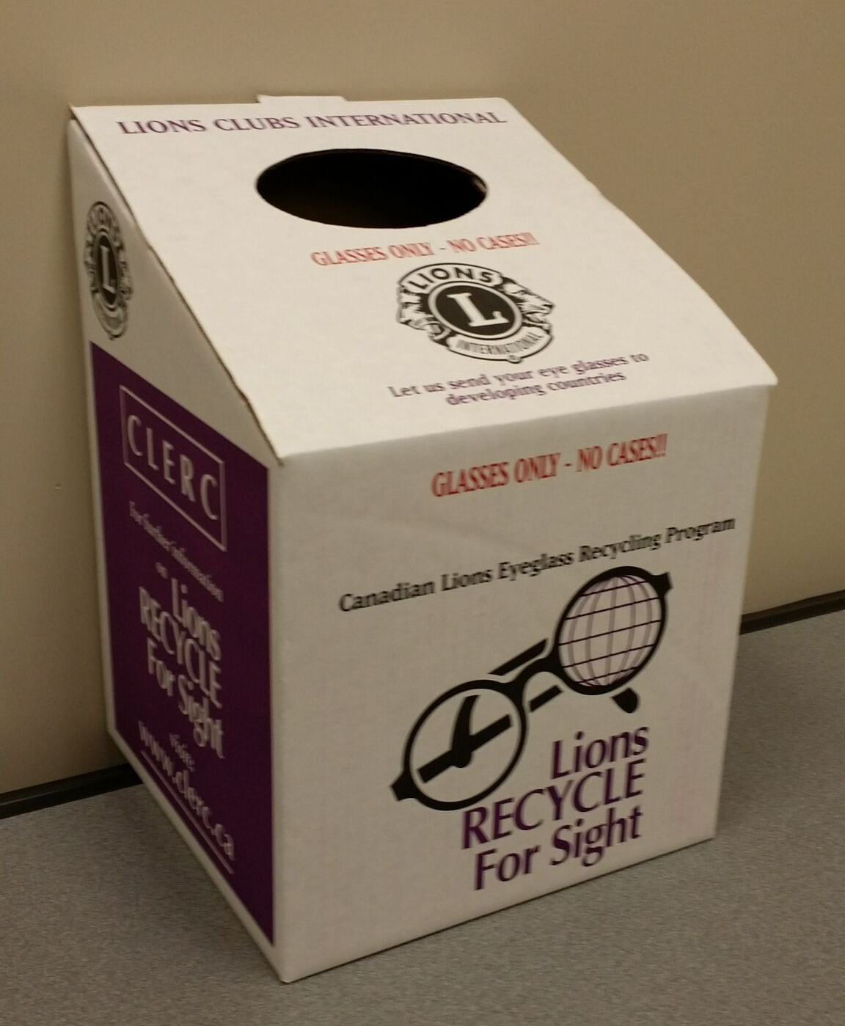

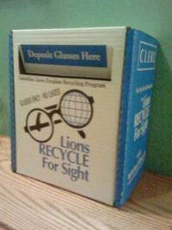
Lions Recycle for Sight Collection Boxes

The Canadian Lions Eyeglass Recycling Centre (CLERC) offers boxes (see image to the left). Currently they will provide your club with collection boxes for CDN$1.02 each plus shipping costs. To request boxes call 1-403-640-1056 and leave a voice message with your request or email your request to: info@clerc.ca.
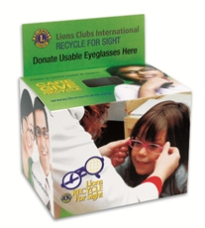
Alternately LCI offers boxes as seen to the immediate right from the Lions Store. You can order them in quantities of ten. Collection Boxes can be ordered from the USA Lions Clubs International Store (part G-1174DS; 10 boxes for US$76.95 plus shipping). Visit the store to order at: https://lionsclubsinternational.myshopify.com/products/g1174ds.

Alternatives:
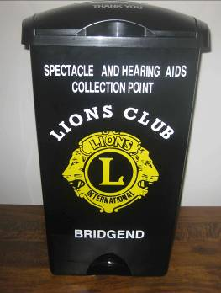
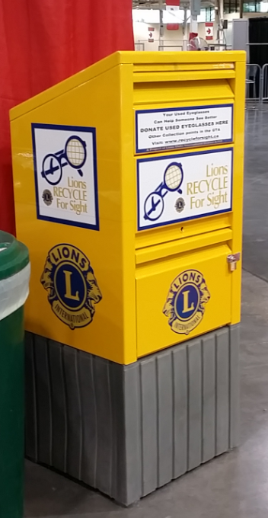
Make a Large decal Using the design: Large Collection Box Decal to make your own collection boxes.

Canada Post Mailboxes

Until 2013 we were able to source surplus mailboxes from Canada Post. I include this information as perhaps you have other ideas for eyeglass collection receptacles which we can used to both collect used eyeglasses and to publicize this important project. The Box at the left has been placed at the Canadian National Exhibition annually for its full duration since 2012. It served both as a billboard for the program and as a receptacle for donations. You can see another example of a collection box used in the UK to the right.

* Reporting and promoting with MyLion

  - Report Your Eyeglass Collections as a one of two Lions Service Area Projects

Collection of used eyeglasses should be recorded by your clubs’ Secretary or alternately your President, Service Chair or Club administrator in MyLion or MyLCI as a Lions Service Area Project under either the Vision or Environment (recycling) categories.

MyLion can be used for promotion:
Any Lion member can post your Recycle for Sight Project as an activity in MyLion.

MyLion for Reporting
Special note: your Club Secretary, President, Service Chair or Club Administrator can turn a Service project (Recycle for Sight) into a reported service activity.
- Use your Internet browser online to access and report all your Club and individual Service Activities through MyLion, or
- use the MyLion Application on your Apple or Android Smartphone to publicize and then report your service activities.

Make sure you count all of your activities in this pursuit: Calling sites to see if pickup required, visits to collect eyewear (count the time door to door), time spent counting, packing and shipping your collections, and of course the number of people involved and the number of glasses (of all types) and hearing aid collected. Each pair of glasses is a person served.

Effective Lions Year 2020-2021 all service reporting in done at: https://app.mylion.org/

  - Report Eyeglass shipments to CLERC.ca

Eyeglasses shipped to the Canadian Lions Eyeglass Recycling Centre (http://www.clerc.ca ) (CLERC) in Canada are automatically counted in Lions Statistics at the District, Multiple District and International levels. Report the glasses you ship to agencies other than the CLERC. This allows LCI to have a better idea of the full scope of our club’s collection efforts in Canada.

Glasses shipped to Medical Ministries International (MMI) Canada will be reported to the CLERC only if you provide the count to their offices when you drop them off and ask that Leanne Ferris their Executive Director report your donation to the CLERC. You should still report all collections in MyLion.

If your club sends collected glasses to other agencies, i.e. VOSH International (Montreal), or other eyeglass recycling agencies in Canada, please email info@clerc.ca with a count of how many pairs you shipped, and to what agency. You should still report all collections in MyLion.

The CLERC has been serving Canadian Lions as one of 18 Global Eyeglass Recycling Centres globally since 1996.

Clubs are reminded to:
- Record in their meeting minutes the numbers of pairs of used eyewear collected by the club.
- Record collection results in MyLion.
- Send the count of all eyeglass shipments to the District Recycle for Sight Coordinator at recycleforsight@a711lions.ca
- If you drop off boxes of Glasses to Mountaineer Movers or MMI In Hamilton please email the count of glasses donated there to info@clerc.ca and copy recycleforsight@a711lions.ca .

The bottom Line as thoughtfully provided by past District A-711 Recycle for Sight Chairperson Georgette Dorcich and paraphrased for the times:

“Let us ask ourselves the following important questions:
- Why are we collecting used eyeglasses?
- What difference does it make to the sight-impaired recipient who the primary entity delivering the glasses to them is; a Lions only mission or a LensCrafters mission with Lions Clubs participating?

If the answer to question 1 is "to give light in the darkness" as per Helen Keller, then the answer to question 2 should be obvious.

I therefore respectfully suggest that - we Lions, as ‘Knights of the Blind’, but when the distance, time or funds prevent from shipping to the CLERC in Calgary, that we continue to ship them to MMI Canada where we can be assured they will reach the needy through their direct missions.”

* Packaging

- * Please send both plastic and metal frames. Do not ship hard eyeglass cases. Loose and broken lenses or damaged lenses and frames should be packaged in a separate box and labelled as “loose lenses and broken glasses“ before shipping.
- If glasses have clip on sunglasses leave them in a hard case or a plastic bag.
- Rather than store glasses for a long time, send them to the recycling centres as soon as possible. Time, extreme temperature / weather conditions may cause damage to frames and lenses, often rendering them useless.
- Pack eyeglasses in a sturdy corrugated box. Layer rows of eyeglasses snuggly together. (Please do not use shredded packing materials, plastic bags or Styrofoam “peanuts”, tissue paper, or newspaper when packing glasses.) Do not individually wrap eyeglasses. Placing glasses in plastic zip lock or equivalent bags is acceptable.
- Seal boxes securely with tape.
- Be sure labels are legible and include your clubs return address (sample labels are provided in Appendix C.
- Used eyeglasses are of no commercial value; therefore, choose the least expensive means of shipping to the recycling center (various Carriers may ship these used eyeglasses to the CLERC for Low cost or no cost (See Appendix B for alternative carriers).
- Label all boxes as “No Commercial Value.”
- Please notify the Canadian Lions Eyeglass Recycling Center before sending them large shipments of eyeglasses 1-403-640-1056 or info@clerc.ca . (by example: multiple skids of eyeglass frames or cases being donated by a manufacturer).

“Loose lenses and broken glasses“ are a source of revenue to help run the Recycle for Sight Program. Loose lenses are sold to a vendor who subsequently ground them down, mixes them with paint that goes on US Highways. Broken glasses are melted down for their metals. This revenue helps keep the program running, so do help contribute these items.

* Shipping Instructions

Since 2016 “Day & Ross Freight” have offered to ship our used eyewear collections for free to the CLERC in Calgary form any of their terminals in Canada.

Note: this free service assumes you a minimum of four or more boxes of eyewear at a time. Day & Ross Freight is not a courier company.

Mountaineer Movers Ltd. In Hamilton, Ontario has agreed to provide storage space for Lions clubs shipping used eyewear in the Greater Hamilton area. They will in turn supply Medical Ministries International (MMI) with glasses or arrange shipping to the CLERC in Calgary.

Lions Clubs in Ontario may alternatively ship or drop off their used eyewear to “MMI Canada” in Hamilton, Ontario via Mountaineer Movers Ltd. (See address/ shipping label sample in Appendix C).

Whether you ship your glasses to Medical Ministries International in Hamilton directly, or via Mountaineers Movers Ltd please email the count of the glasses you shipped to info@clerc.ca, or if you physically drop glasses off at the shipping entrance of MMI please go upstairs to their offices at the front of the building and give the staff there a count of glasses dropped off and ask them to add your total to the next report they send to info@clerc.ca.

In summary at this time if you can ship your collected eyewear by one of these means:

- * Drop your packed boxes off at a Day & Ross Freight Depot https://dayross.com/terminal-locations (follow the detailed instructions on the next page).
- “Mountaineer Movers Ltd.” in Hamilton, Ontario has agreed to be our storage depot destination for used eyewear. They will store eyewear until it can be either transferred to MMI, which is located nearby, or they will make subsequent arrangements to ship surplus quantities to the CLERC in Calgary. A Sample address label for Mountaineer Moving can be found in Appendix C of this document.
- District A-711 Recycle for Sight Coordinator, Lion Dave Bhatia is currently accepting used eyeglasses from District A-711 clubs. Call 647-294-2840 bhatiadave@yahoo.ca.
- Another alternative means of shipping at low or perhaps no cost to the CLERC in Calgary: Contact the Not for Profit shipping organization: “Truck for Change Network” Contact Betsy Sharples, Executive Director at betsy@trucksforchange.org. Visit http://trucksforchange.org/for-charities/ to learn what they can do for you.

*Shipping for free With Day & Ross Frieght

Here is how it works:
- Find your closest Day & Ross Trucking Terminal at https://dayross.com/terminal-locations

- Customized the shipping label on Page 18 of this guide by adding your clubs mailing address, and then place one of these labels on each of your packed boxes.

- Fill In and print a Day & Ross Bill of Lading (available at their locations). You can download a partially prepared template here as Bill of Lading in PDF format.PDF Bill of Lading as MS Excel spreadsheet. Here is a guide to the areas of the Bill of Lading you will need to customize. Input your information in the fields that are highlighted on the forms available at the links above.
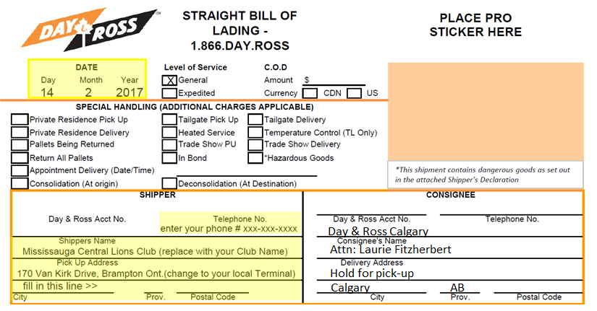

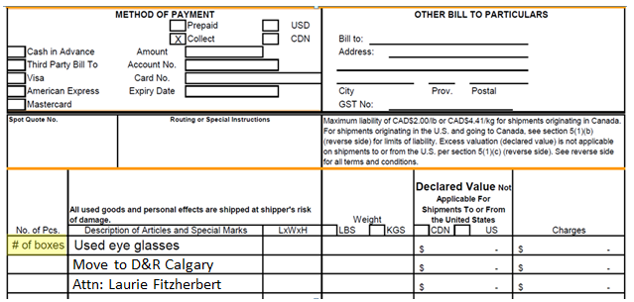

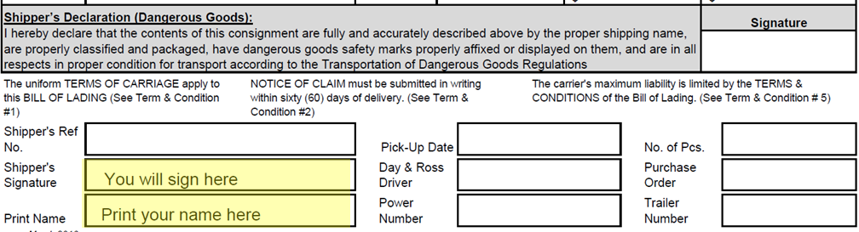

- Take your packed and labelled boxes of glasses to the Day & Ross Freight
terminal closest to your location. Find your closest Day & Ross Terminal at: https://dayross.com/terminal-locations
- When you arrive at their closest terminal (As an example the Brampton Ontario Terminal is located at 170 Van Kirk Drive.) Tell the security guard at the gate you are dropping off a shipment. Drive to the main building and go to the office with your prepared Bill of Lading. They will instruct you to go to a specific loading dock elsewhere in the Terminal to unload your boxes. Click this link to see their Brampton location on Google Maps. Ensure you get a gate pass to leave the facility before you drop off your boxes at the specified loading dock.

- When the glasses arrive at the depot in Calgary (per the information on your shipping label) Laurie Fitzherbert will call the CLERC to advise of the arrival and coordinate transfer to the CLERC.

- Day & Ross is a shipping company and not a courier service. Please try to ship a minimum quantity of four boxes at a time.

Labeling instructions

Please adapt and use the mailing labels and Fragile Notices located in Appendix C

Requests for Glasses for Missions

The Canadian Lions Eyeglass Recycling Center has criterion regarding the requirements of Missions Requesting quantities of Eyewear. Amongst these are that they will only ship to pre-approved organization in Canada. For additional details reference WWW.CLERC.CA or email info@clerc.ca or leave a message at 1-403-640-1056.

Missions (Staffed with Ophthalmologists, Optometrists and Lion Volunteers) then apply to get quantities of eyeglasses. Click on the picture to watch a 4-minute video about a Mission to Mexico:



*Discount Programs for Lions Members

Hakim Optical is offering Lions & Family members 1 10%discount over and above any promotions currently being offered at the time you are purchasing your new glasses. To obtain this offer, please email info@clerc.ca your Name, address, Lions Club Name, your District and your Lions Club Membership Number; your email address and your phone number. Within a week you will receive the promotion information by a return email.

View the offer on the next page or download it from the following link: http://www.lionscentral.com/Hakim - Lions Preferred Corporate Discount Program.pdf



Appendix A: “Find a Club” shows “Eyeglass Collection Points”

When you complete the Club collection location form (IAD-404) Lions CIubs International will post up to 60 of your club's eyeglass collection locations in the "Find a Club" section on the LCI Web site.

Here is an example of my Club’s Listing:

NOTE: Besides the listing of your Recycle for Sight collection points, LCI also posts current activities from your Monthly Reports (entered through LCI ).
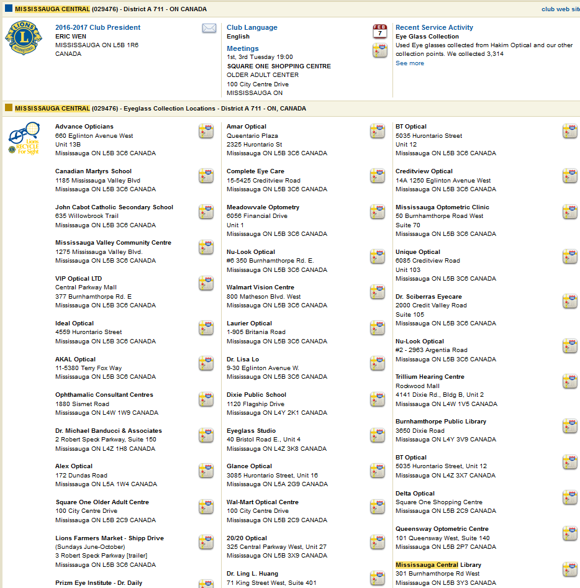

* Appendix B: Shipping Companies / Arrangements

An alternate shipping method involves the use of the Trucks for Change Network™. They were set up to help charitable organizations ship goods at low or in some cases no cost.

The prime contact fort this organization is their Executive Director: Betsy Sharples. Betsy can be reached via email at: betsy@trucksforchange.org www.trucksforchange.org

To qualify for their service, you must first complete a Charity Client Application and Agreement. Then before each shipment you will be required to complete a MoveMatrix™ – Charity Need Summary detailing just what is being shipped (W5).



* Appendix C: Shipping Labels and Fragile Label

Adapt and use the next two labels to ship direct to:
The CLERC in Calgary, Alberta via DAY & ROSS FREIGHT
Copy and Edit to apply your clubs shipping and return address


Your Lion Club Name
Mailing Address (not P.O. Box)
City, Ontario
XXX XXX

Canadian Lions Eyeglass Recycling Centre

CALGARY DAY & ROSS TERMINAL
C/O LAURIE FITZHERBERT COLLECT.
Receiver: HOLD FOR PICK UP - PHONE UPON ARRIVAL 403-289-5274 OR 403-852-6547 OR 403-640-1056

BOX ___ of ___

Used Eyeglasses
NO COMMERCIAL VALUE

FRAGILE – Do Not Crush


Your Lions Club Name
c/o your return shipping address,
your city, your province
X#X #X#

To: CALGARY DAY & ROSS TERMINAL
C/O Laurie Fitzherbert COLLECT
Receiver: HOLD FOR PICK UP - PHONE UPON ARRIVAL
Canadian Lions Eyeglass Recycling Centre
403-289-5274 OR 403-852-6547 OR 403-640-1056

BOX ___ of ___

NO COMMERCIAL VALUE

FRAGILE – Do Not Crush

Your Lions Club Name
c/o your return shipping address,
your city, your province
X#X #X#

To: CALGARY DAY & ROSS TERMINAL
C/O Laurie Fitzherbert COLLECT
Receiver: HOLD FOR PICK UP - PHONE UPON ARRIVAL
Canadian Lions Eyeglass Recycling Centre
403-289-5274 OR 403-852-6547 OR 403-640-1056

BOX ___ of ___

NO COMMERCIAL VALUE

FRAGILE – Do Not Crush

Adapt and use this format to ship direct to
M.M.I. Canada or the CLERC VIA Mountaineer Movers Ltd.
Copy and Edit to apply your clubs shipping and return address

Your Lion Club Name
Mailing Address (not P.O.Box)
City, Ontario
XXX XXX

Medical Ministries International or
Canadian Lions Eyeglass Recycling Centre
c/o Mountaineer Movers Ltd.
Attn: Lion Wendy Mans-Keddie
487 Grays Road
Hamilton, Ontario
L8E 2Z5

BOX _____ of _____

Used Eyeglasses
NO COMMERCIAL VALUE

FRAGILE – Do Not Crush

Adapt and use this label to ship direct to:
The CLERC in Calgary, Alberta
Copy and Edit to apply your clubs shipping and return address

Your Lion Club Name
Mailing Address (not P.O.Box)
City, Ontario
XXX XXX

Canadian Lions Eyeglass Recycling Centre
c/o MATCO
5003- 52Ave SE
Calgary, Alberta
T2C 4N7

Dispatch Phone: 403-236-5010 Attn: Wes Robinson

Upon Arrival Phone Lion Gordon Prusky at 403-289-5274

BOX ___ of ___

Used Eyeglasses
NO COMMERCIAL VALUE

FRAGILE – Do Not Crush

Adapt and use this label format to ship direct to:
Medical Ministries International Canada
in Hamilton, Ontario
Copy and Edit to apply your clubs shipping and return address

Your Lion Club Name
Mailing Address (not P.O.Box)
City, Ontario
XXX XXX

Medical Ministries International
621 Barton Street East
Hamilton, Ontario
L8L 3A1

BOX _____ of _____

Used Eyeglasses
NO COMMERCIAL VALUE

FRAGILE – Do Not Crush

Fragile Labels:
Cut these out and apply these fragile notices liberally to your shipping boxes

 | FRAGILE  Used Eye Glasses  DO NOT DROP

FRAGILE
Used Eye Glasses
DO NOT DROP

FRAGILE
Used Eye Glasses
DO NOT DROP

FRAGILE
Used Eye Glasses
DO NOT DROP

